Too much kangaroos in australia, this is an « environmental disaster »

Kangaroos are one of australia’s greatest symbols.
They were protected for years but now they are considered like pests for the most of Australian peoples. They invade towns and farms, steal cattle’s food, cause damages and are a major cause of vegetation loss.
In august 2018 Canberra get invaded by herds of kangaroos in search of food after a severe drought.
Another example : Acording to insurers, Kangaroos would be the cause of 80 % of collisions between vehicles or animals In Australia. They are no longer afraid of humans, they are like city pigeons which don’t take care of humans and let crush themselves by cars.
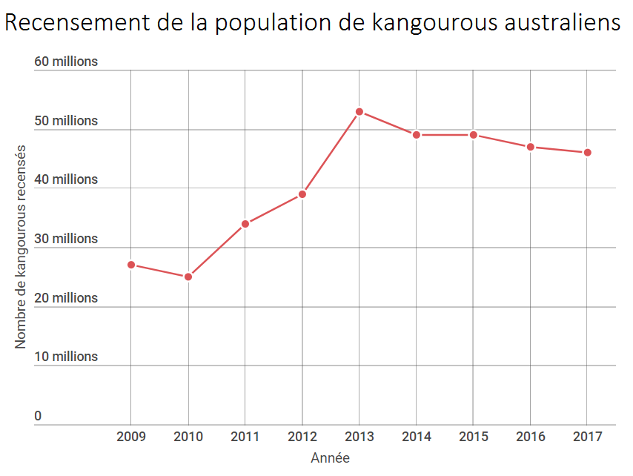
The reason of Kangaroos migration could be explained by their increasing number of 47 million, which is more than double of Australia’s population. There is no enough food for kangaroos and the drought is killing what is left. Their last solution is to head to towns to look for food.
With the human protection (national parks) and the abundant source of food in the cities, kangaroos continue reproducting themselves and their number keep growing with the problems that it cause, instead get stabilized if there was no human intervention. Fortunately, Australia started to act to reduct the population by encouraging hunters and allowing kangaroo meat, but some Australians disapprove this practice despite its necessity.

